
Internship report – Bachelor’s Degree Programme
Technology, Communication and Transport

SMART WATER FACTORY

AUTHOR/S Sameer Karn
Lai Ngoc Dung

SAVONIA UNIVERSITY OF APPLIED SCIENCES
Field of Study
Technology, Communication and Transport
Degree Programme
Degree Programme in Information Technology, Internet of Things
Author(s)
Sameer Karn, Lai Ngoc Dung
Title of Thesis
Smart Water Project
Date | 20/2/2022 | Pages/Number of appendices | 5
Client Organisation /Partners
Savonia University of Application, Viimatech Company
Abstract
Background: Optimizing performance of the industrial pumping system is an increasing demand nowadays. The purpose of optimization is to save the resource and energy consumption, enhance the productivity and extend the life cycle of the pumping devices. For these reasons, variety of IOT technologies can be applied in this field to continuously monitor and optimize the performance of pumps. With the support of Savonia University of Application and Vimatech company, we implement a smart water project in the Savonia water factory. The project uses the VT03 pumping monitor to record the activities of the pumps and analyze the data.
Results: The result showed the potential ability to combine greater efficiencies with sensors and software to regulate and control flow and pressure. Two small abnormal were detected and classified. The data collected from the sensor helped to understand the current condition of the pump as well as the events had happened on the system in the past. Then it could improve the result of maintenance process.

Keywords

INTRODUCTION
The Internet of Things (IoT) revolutionary technologies have transformed the industrial product in many aspects. One of the fields can be benefited from the advance of IIOT technology is pumping factory industry. In the past, the conventional pumping systems need to be checked up and maintained manually, which leads to the discontinuity in pumping monitor and sometimes it leads to delay in error detection and correction. IIOT technology can offer solutions for continuously checking up the pumps and pipe-line condition by using a sensors system and computer power. Hence, any trouble with the systems as well as abnormal performances can be detected early and system failures can be avoided. Application of IIOT in industrial pumping system hence reduces overall maintenance costs and life-cycle costs.
From this concept and being approved by Savonia University of Application Technology, we have a short internship period to practice IIOT technology on the Savonia water factory. The devices used in internship project are VT03 equipment from Viimatech vendor. The object of the internship is to collect the data of pumping performance, analyze data to detect any abnormal and suggest a solution for continuous improvement activities to achieve pump Best Efficiency Point.

SMART WATER INTERNSHIP PROJECT DESCRIBE

Viimatech VT03 pumping sensor
The VT03 device uses non-invasive sensor (also known as split core current transformer) to measure the current and power of the pumps. Two probes are clamped around the power source of the pumps. When the current goes through the power line of the pump system, it will create a magnetic field around a current-carrying conductor, the sensors now work as inductors that are able to capture the change of the current. The induction current appearing in the coils of the sensor is used to calculate the intensity of the current in the power line. Two main parameters monitored by the sensors are current phases and current loop. From these parameters, four index are obtained to evaluate condition of the pumping system: running cycle length, runtime average phase current, time between cycles and motor duty cycles.
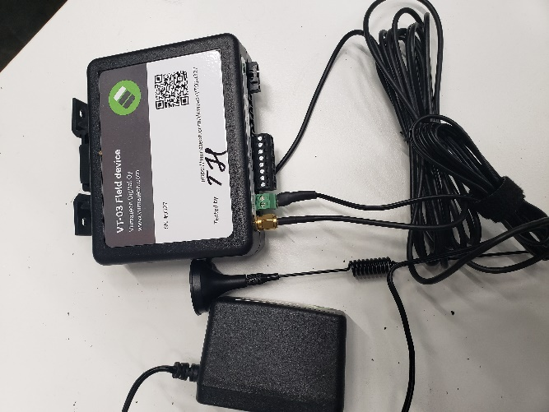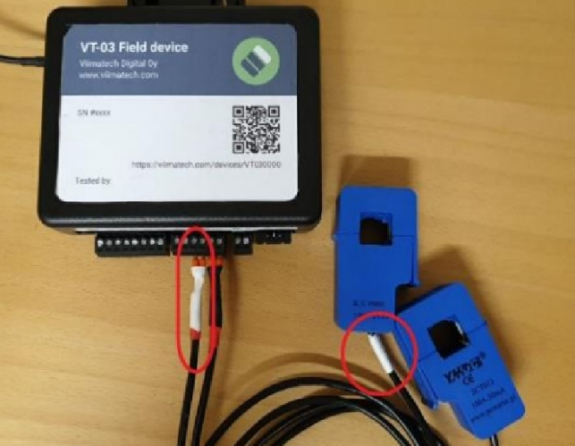
Figure 1: VT03 pumping monitor devices
The data is collected by these sensor and results are sent to the cloud by a small antenna. The vendor provides a web-based user interface with visualization graph and data storage services. Hence the users are able to access the history data of the pump performance. Any abnormal activities can be easily seen on the user interface.

Devices Implementation
The sensor VT03 devices are installed on the main pumping in Savonia UAS water factory. Two probes are respectively wrapped around the hot wire and neutral wire of the pump power wire. There are 5 main steps to set up the sensor system:
- Step 1: Connect the 24VDC power input to the terminal X3 POW.
- Step 2: Attach the current transformers to the motor phase conductors.
- Step 3: Connect the other inputs to their correct terminals.
- Steo 4: Attach VT03 to DIN rail
- Step 5: Connect the power cable. When VT03 boot for the first time, the indicator LED will blink to show the status of the device. Red led will turn on 10s after the power cable is connected. Blue led indicates the connection start opening, no data is transmitted yet. When green led turn on then the device is fully operated.
The installation failure can be detected from the Led indicator. If the device does not send data after 10 minutes, reboot the device by disconnecting the power, waiting 30 seconds and connecting the power back.
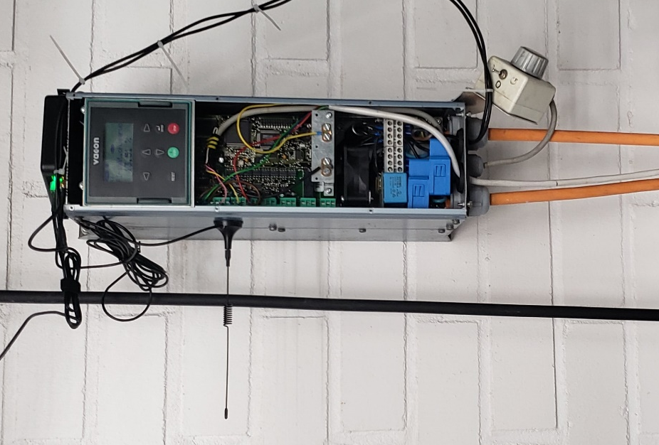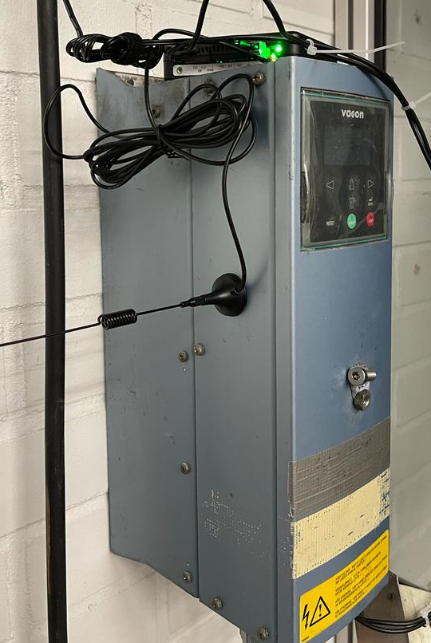
Firgure 2: The VT03 installated on Savonia UAS pumping system.

RESULTs
The performance of the VT03027 is observed in 4 weeks. The sensor is installed to take measurement sample one time each hour. The current draw from normal operation of the pumping system is 7.6 measurement units on average. If the amount of the current used increased dramatically, the pump is probably jammed. If the current consumption is higher than average in a long duration, it properly indicates that the pump needs to lubricate, check-up and maintain bearing bush and ball bearing to reduce friction. On the other sides, a sudden quick drop in current implies a blockage in the suction line or pin shear. The data from sensor can help to detect this abnormal within milliseconds of the occurrence. Hence the system can be shut down early to avoid severe damage to the motor or pump because of overheating. The data collected in four weeks is presented in the graph below:
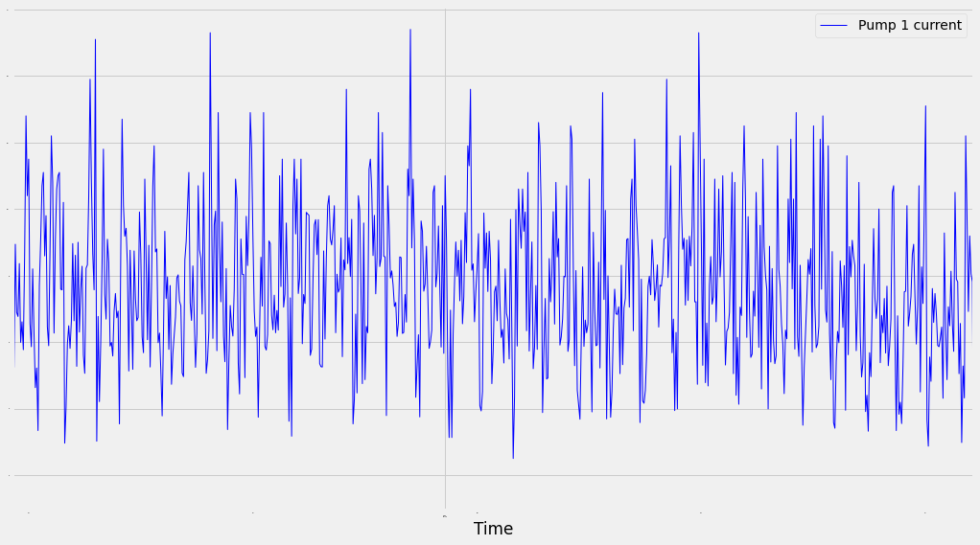
Figure 3: Data from usage history of the pumper in 30 days
We create a python program to visualize the data in python. The user can enter the period of operation to create a graph of energy consumption in this duration. The graph below demonstrates the analyzing result in period of 7 days:
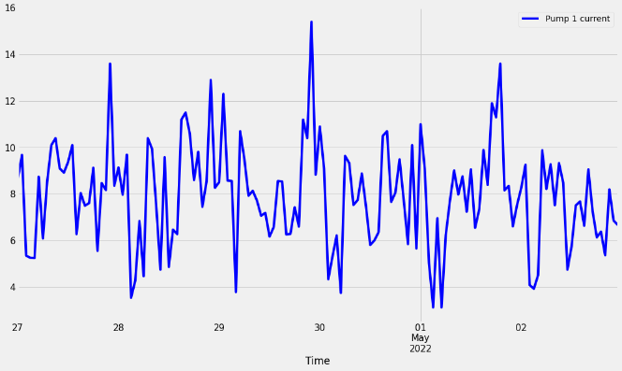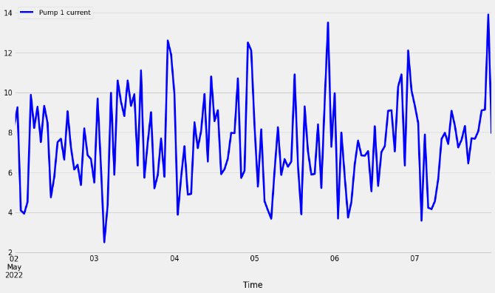
24/7 – 2/5 7/5 – 12/5
Figure 4: Example of the usage in one week
An energy consumption by hour is created to analyze the peak and trend of pumper performance on average. The pumper is least active in the morning from 3AM - 7AM and most active in the evening from 21PM - 23PM. From 6AM – 18PM, the pumper usually runs constantly and steadily. All the data point is grouped by day and then average consumption is calculated for each day. From average performance graph, user can compare these values to detect any abnormal event happened in the observed period. In details, there were four points that the sensor recorded the abnormal high measurement, they are 20/04, 23/04, 30/04, 09/05. The measurement was high as 15, approximately 16.
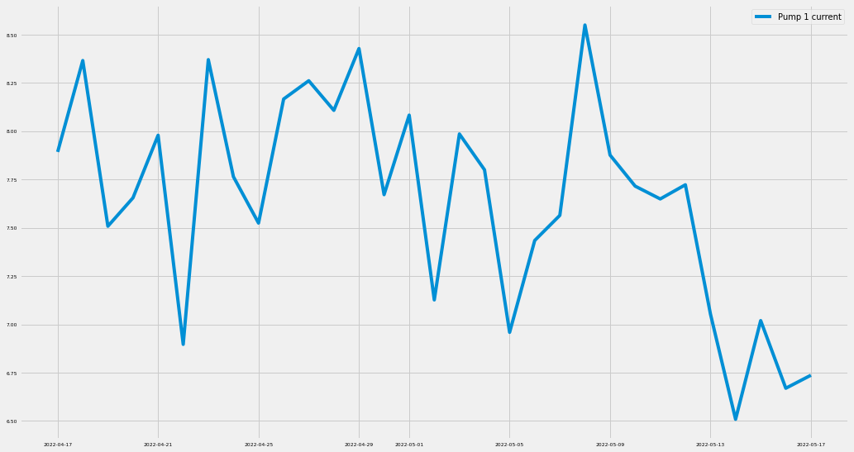
Figure 5: Average power consumption by day
In order to inspect the relationship between the daily usage history with other variances provided by Viimatech, we used Correlation Matrix. A correlation matrix is simply a table which displays the correlation coefficients for different variables, and correlation coefficients are indicators of the strength of the linear relationship between two different variables. If the correlation coefficients are greater than 0.7 or smaller than -0.7, then it can be concluded that there is relationship between 2 properties. There result showed a weak relationship between these properties with daily usage, in range of 0.2 to 0.3. Therefore, there is no linear relationship between them, or the usage is independent of other properties.
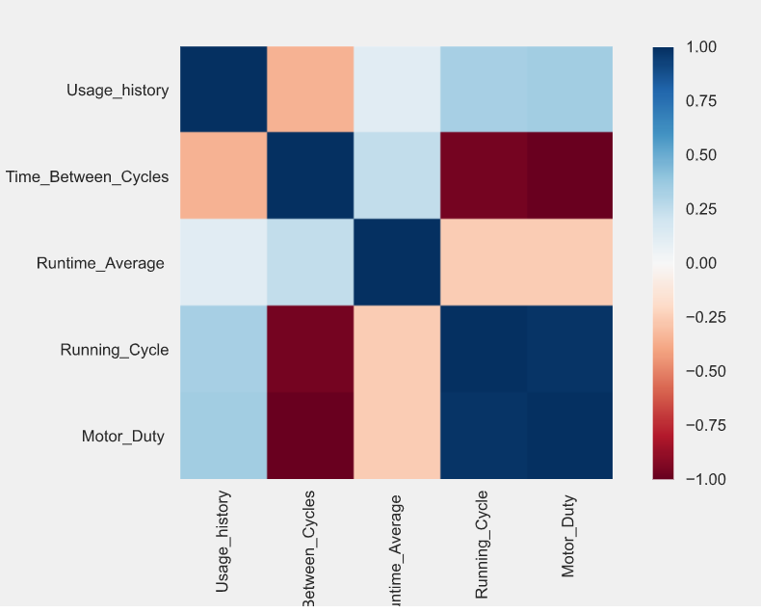
Figure 6: The Correlation Matrix between usage history and other variables
A long short-term memory (LSTM) neural network is used to predict the usage of the pumper in the next hour. The training data set include 720 values in 30 days, provided by Viimatech. After training, the model will take an input array of usage in 10 hours and predict the usage for the next 10 hours.
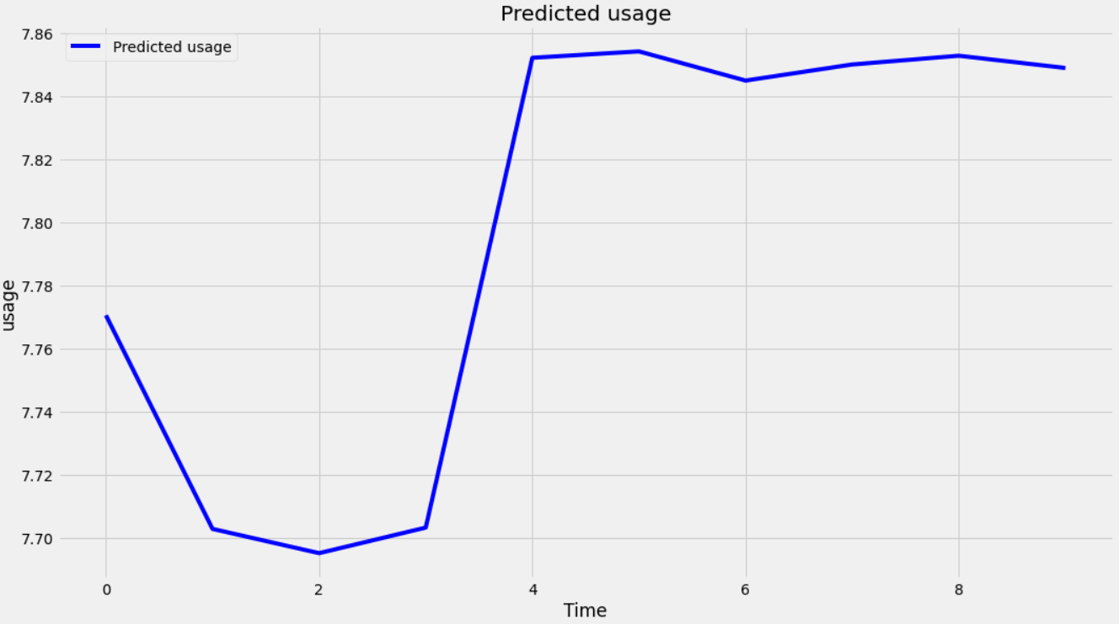
Figure 7: Predict the usage in the next 10 hour
The detail data set and program are put on the Github. Please visit the following link for more information: https://github.com/IsaacLai1/Smart-water-project.git

DISCUSSION
The application of VT03 device on the water pumping system provide valuable data about the condition of the pumps. The data indicates that the pumping system operated steadily in the observation period. Data collected from the pump can be used in combination with machine learning tool to reach the Best Efficiency Point. It also provides a fundamental base to build a digital twin version of pumper system in the future. The MQTT protocol can be applied to improve the performance of the sensor system.

